National College of Computer Studies

Paknajol, Kathmandu

**Lab Report on**

**Theory of Computation**

**Submitted by: Submitted to:**

Atullya Maharjan Prashant Gautam

BSc. CSIT 4th Semester NCCS

Roll. No: 05Lab 2

1. **WAP to design a DFA for the language of string over {0.1} in which each string end with 11**

#include <iostream>

#include <string>

using namespace std;

int main(){

string str;

char state = 0;

cout << "Enter the string: ";

cin >> str;

for (int i = 0; i < str.length(); i++){

if (str[i] != '0' && str[i] != '1') {

cout << "String not accepted.\nPlease enter a string over {0,1}" << endl;

return 0;

}

if (state == 0 && str[i] == '0')

state = 0;

else if (state == 0 && str[i] == '1')

state = 1;

else if (state == 1 && str[i] == '0')

state = 0;

else if (state == 1 && str[i] == '1')

state = 2;

else if (state == 2 && str[i] == '0')

state = 0;

else if (state == 2 && str[i] == '1')

state = 1;

}

if (state == 2)

cout << "String accepted";

else

cout << "String not accepted";

return 0;

}





1. **WAP to design a DFA accepting the string over {a,b} such that each string does not end with ab**

#include <iostream>

#include <string>

using namespace std;

int main()

{

string str;

char state = 0; // initial state (q0)

cout << "Enter the string: ";

cin >> str;

for (int i = 0; i < str.length(); i++)

{

if (str[i] != 'a' && str[i] != 'b')

{

cout << "String not accepted.\nPlease enter a string over {a,b}" << endl;

return 0;

}

if (state == 0 && str[i] == 'a')

state = 1;

else if (state == 0 && str[i] == 'b')

state = 0;

else if (state == 1 && str[i] == 'a')

state = 1;

else if (state == 1 && str[i] == 'b')

state = 2;

else if (state == 2 && str[i] == 'a')

state = 1;

else if (state == 2 && str[i] == 'b')

state = 0;

}

if (state == 0 || state == 1)

cout << "String accepted";

else

cout << "String not accepted";

return 0;

}





1. **WAP to design a DFA for the language of string over {a,b} such that each string contain “aba” as substring**

#include <iostream>

#include <string>

using namespace std;

int main()

{

string str;

char state = 0; // initial state (q0)

cout << "Enter the string: ";

cin >> str;

for (int i = 0; i < str.length(); i++)

{

if (str[i] != 'a' && str[i] != 'b')

{

cout << "String not accepted.\nPlease enter a string over {a,b}" << endl;

return 0;

}

if (state == 0 && str[i] == 'a')

state = 1;

else if (state == 0 && str[i] == 'b')

state = 0;

else if (state == 1 && str[i] == 'a')

state = 1;

else if (state == 1 && str[i] == 'b')

state = 2;

else if (state == 2 && str[i] == 'a')

state = 3;

else if (state == 2 && str[i] == 'b')

state = 0;

else if (state == 3 && str[i] == 'a')

state = 3;

else if (state == 3 && str[i] == 'b')

state = 3;

}

if (state == 3)

cout << "String accepted";

else

cout << "String not accepted";

return 0;

}





**LAB 1**

**1 Construct a dfa over alphabet ∑={0,1} that accepts stringwith Even 0, Odd 1.**

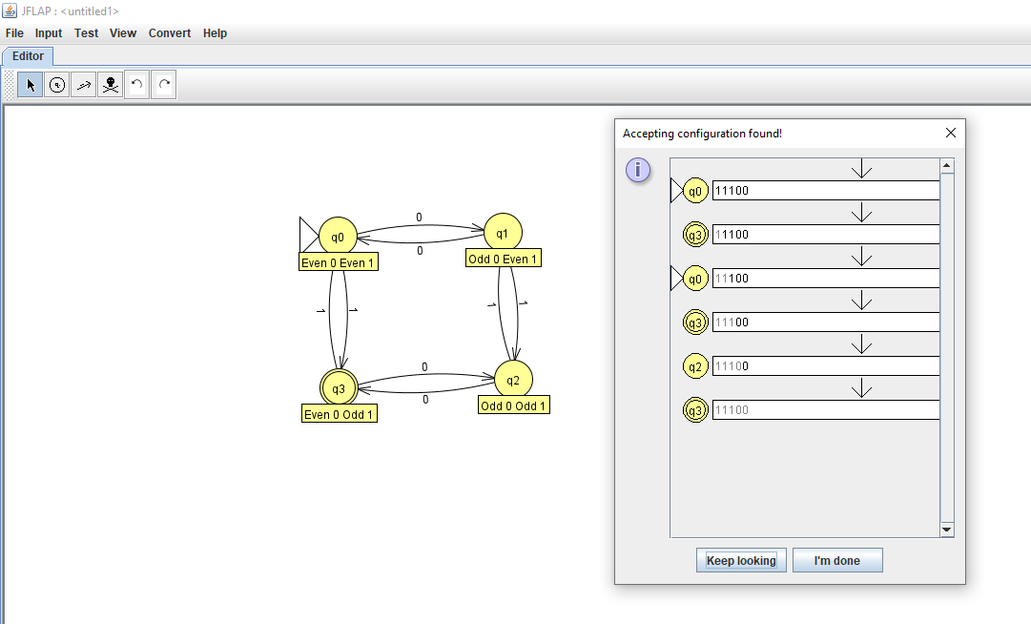

2. **Construct a dfa over alphabet ∑={0,1} that accepts string ending with 01.**

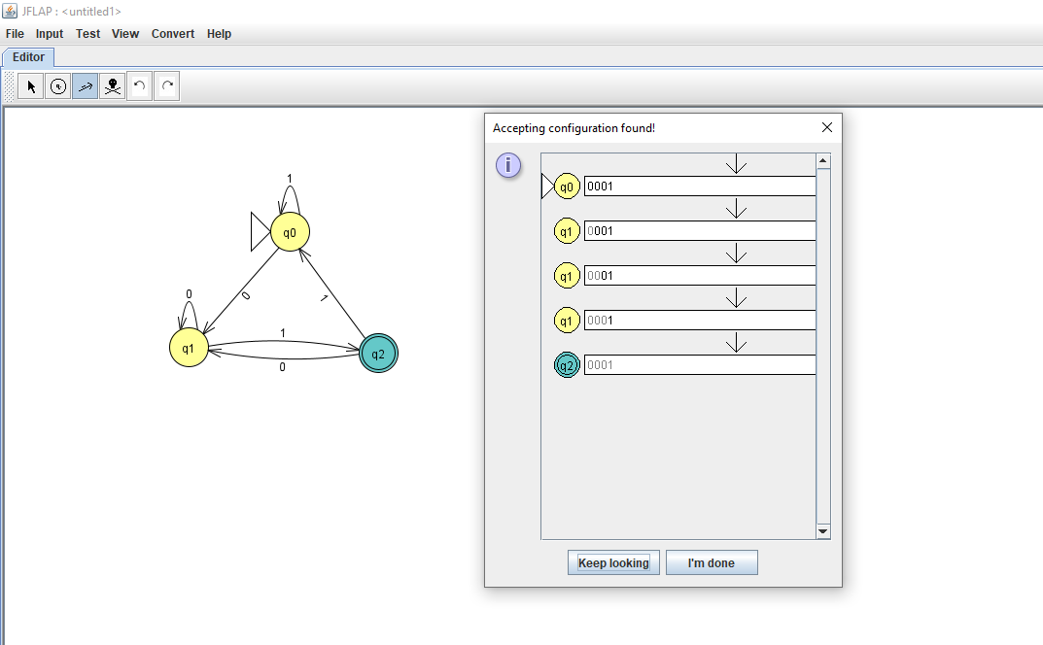

3. **Construct a nfa over alphabet ∑={0,1} that accepts string ending with 01.**

